# Install Java:

Step1: Go to Java https://[www.oracle.com/in/java/](http://www.oracle.com/in/java/) and latest version of java (Java SE Development Kit 18.0.2). and download JDK (Java Development kit).

Step2: Click on X64 Installer and download the EXE file. Run the EXE file.

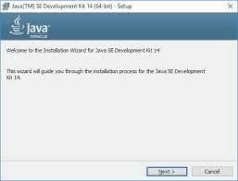

Step3: To check the installation, go to command prompt and type java ---version

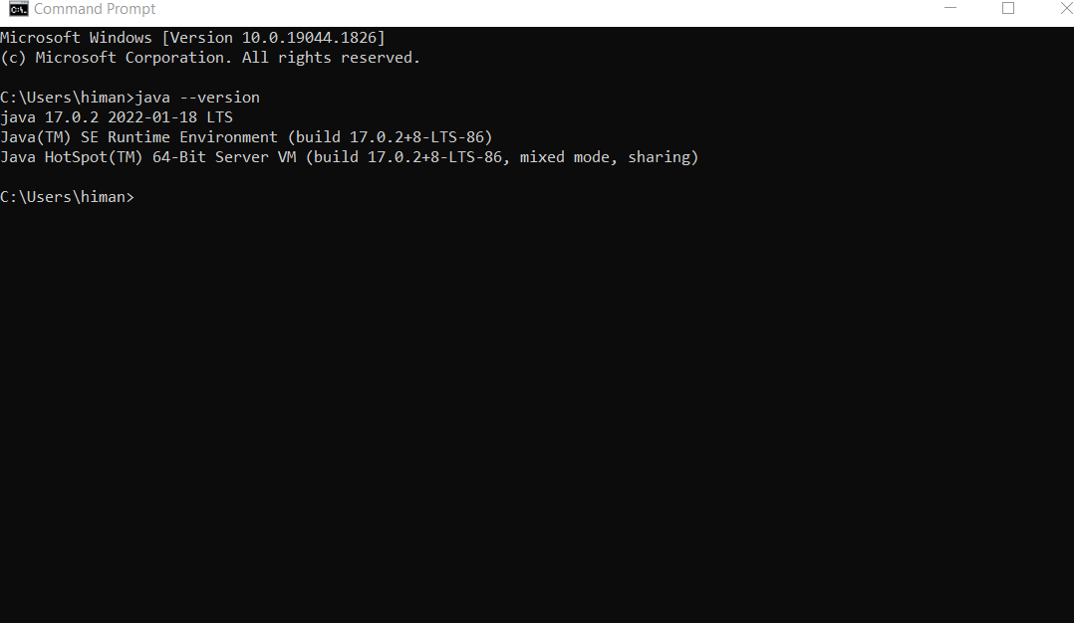

# Set Path:

Step4: Copy the path of JDK which will be shown during installation. Default path is C:\Program Files\Java\jdk-18.0.2

Step4: System Properties -> Advanced -> Environment Variables -> System Variables ->

Step5: Double Click on Path -> Click on New to create a new Path -> Paste the copied path -> Click OK

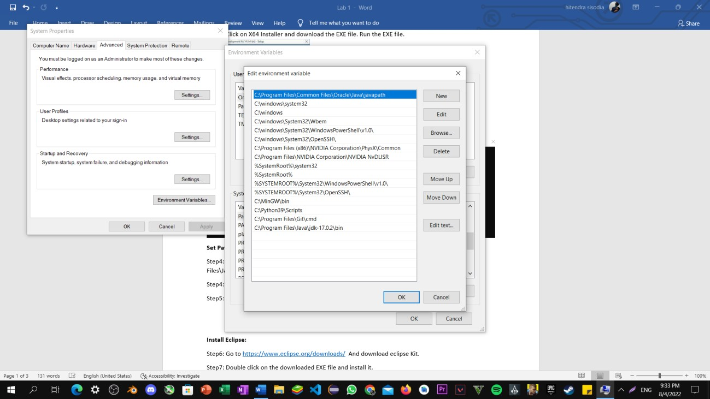

# Install Eclipse:

Step6: Go to <https://www.eclipse.org/downloads/> And download eclipse Kit.

Step7: Double click on the downloaded EXE file and install it.

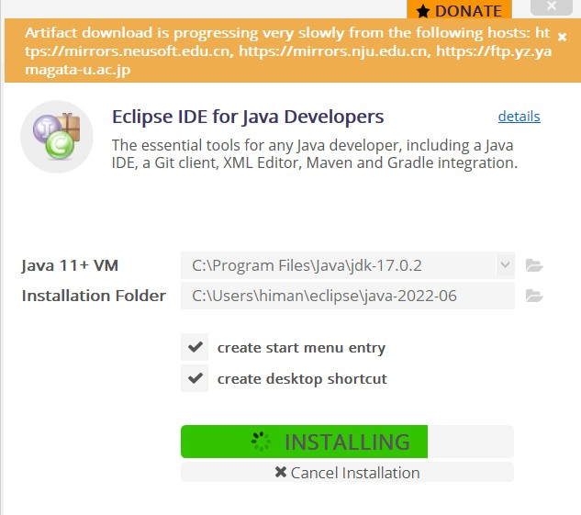

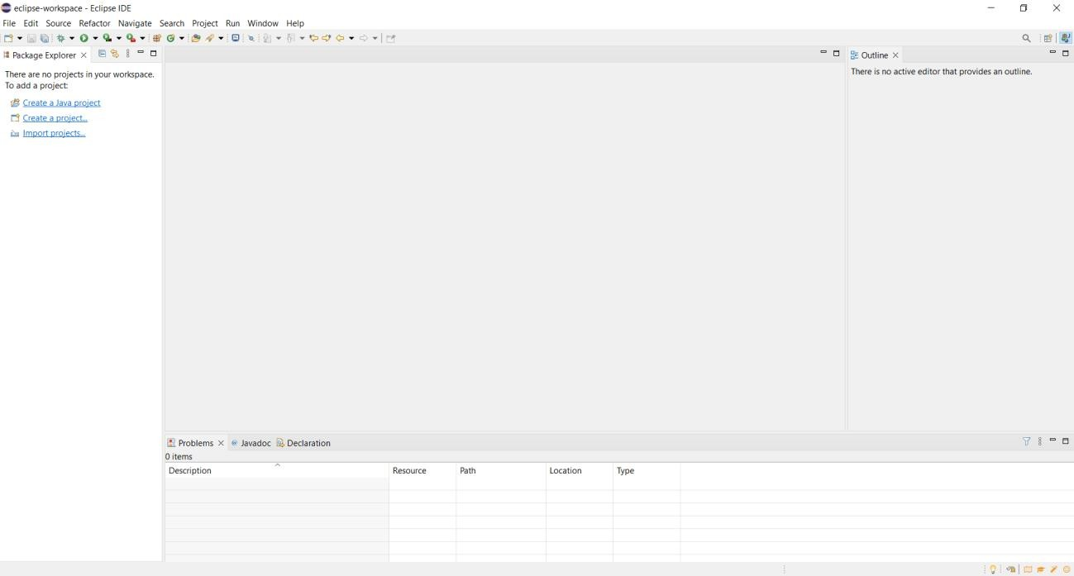

**Ques1**: Print Hello World.

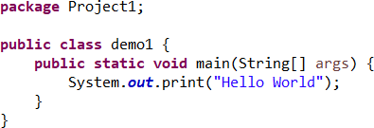**Source Code**

**Output**

